D605 Task 2: Solve and Optimization Problem

By: Kevin Sandoval

A.
The optimization problem in the given scenario is to minimize the total shipment costs to all centers, while ensuring that capacity needs are still met. The key word here is minimized, which implies that it will be an optimization problem.
B1.
From the “Amazon Air Optimization Solution” document file provided in the assessment page:
Objectives
The first objective is to minimize cost. That looks like:
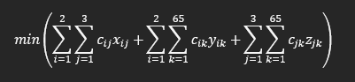
B2.
From the “Amazon Air Optimization Solution” document file provided in the assessment page:
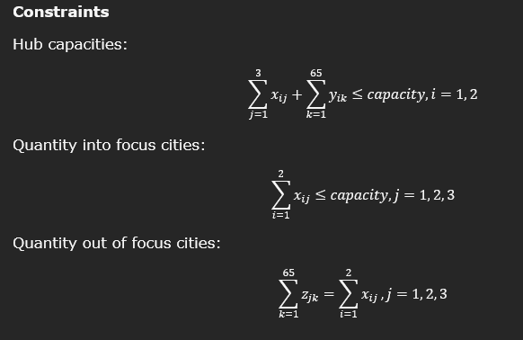

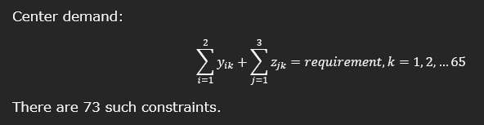
B3.
From the “Amazon Air Optimization Solution” document file provided in the assessment page:
Variables
x_{ij} = quantity sent from hub i to focus city j, i= 1, 2, j = 1, 2, 3
y_{ik} = quantity sent from hub i to center k, i=1, 2, k = 1, 2, …65
z_{jk} = quantity sent from focus city j to center k, j = 1, 2, 3, k = 1, 2, …65

There are 189 variables, excluding the hub, focus city, and center combinations, that are disallowed for distance reasons.
C.
From the equations and inequalities shown in parts B1 and B2, we can see that the objective and constraints are linear. Thus, we will be focusing on using the optimization model of linear programming problems. This then means that the best method will be the Simplex method.
C1.
The method that I will use is the Simplex method. Since the optimization problem appears to be linear, we know that “there will always be an optimal solution that lies at a vertex.” (Williams, H. P. 2013). Because of this, linear problems are easier to solve, and the Simplex method works by only examining the vertex solutions (Williams, H. P. 2013). This makes the process much easier and should be computationally inexpensive.

C2.
To solve this problem, I will use Python in a Jupyter Notebook file to create the code. I will implement the Simplex method and then analyze and interpret the results of the analysis.
D.
One risk of using the Simplex method is degeneracy. There are some issues that may arise with redundant constraints, many constraints intersect at a single point, multiple optimal solutions exist for the dual problem, and other issues. (Fiveable Library, 2024). A limitation of the Simplex method is that it only works for linear problems and not non-linear problems. This makes the method not as robust for use when other problems may arise.
E.
Fiveable Library(Aug. 21st, 2024) 3.2 Simplex Method Retrieved March 31st, 2025 From https://library.fiveable.me/combinatorial-optimization/unit-3/simplex-method/study-guide/TIZaB2147pGFM85n
WGU (n.d.) Lesson 1.1: What Are Optimization Models? Retrieved March 31st, 2024 From D605: Optimization Course Materials
WGU (n.d.) Lesson 2: Optimization Considerations Retrieved March 31st, 2024 From D605: Optimization Course Materials
Williams, H. P. (2013). Model building in mathematical programming. John Wiley & Sons, Inc.

